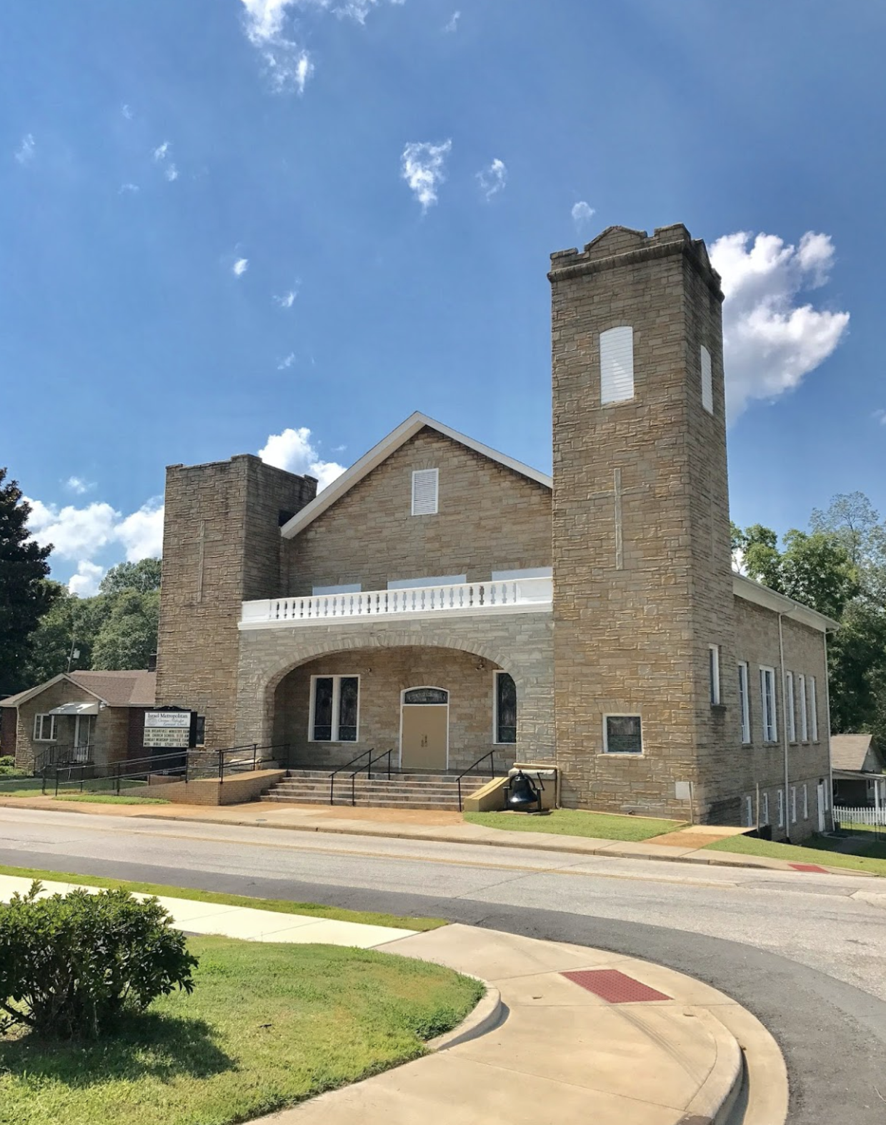
ISRAEL METROPOLITAN CHURCH
www.israelcmechurch.org
PLANS
REOPENING

Introduction
O
n Wednesday, March 11, 2020, The World Health Organization declared the rapidly spreading Coronavirus (COVID-19) outbreak a pandemic. At that time the decision was made – rightly – to cancel services for at least four weeks. Since that time the pandemic has grown in ways few imagined and has restricted our ability to gather together in person. As a faith community we immediately responded to these restrictions by adapting to online virtual services as our primary way of worship, the continuing of our teaching opportunities each week, providing free conference call access to all Church School teachers who desire it, and working with our Class Leaders to ensure that every member in our church directory was contacted and needs were periodically accessed.

Effective March 1, 2021, Gov. Henry McMaster announced that COVID-19 safety measures related to the approval of mass gatherings in South Carolina would be terminated. However, recommendations were released to “Limit attendance of large gatherings to either 50% of the events space’s posted occupancy limit or fewer than 250 people. With that being said, it is time to start on the gradual, responsible and safety conscious road to reopening our church campus. This will be done with government, CDC and other health professionals’ guidelines in mind. Currently, we are in “Phase 0” – only meeting online. Phases are outlined below and are based on changing health trends and guidelines.

Executive Summary
Israel Metropolitan CME Church leaders are committed to making each service the best it can be while still submitting to the larger scope of wisdom regarding in-person gatherings. Clearly, this situation is fluid, yet, in spite of the uncertainty, we have been working on a phased plan to reopen our campus based on the best available information. This plan prioritizes love for our neighbors by keeping people safe (Mt 22:39), showing proper, biblical respect for our government officials (Rom 13:1), and demonstrate that we trust our Church family to make wise decisions.

There is no question that we desire to gather in-person. But we are committed to doing so in a safe and responsible way. A phased plan will not only help avoid gathering too soon but also not hold our church in this online only era for longer than needed. Deciding how to move through the phases is rather complex. Although we are monitoring the situation and working in conjunction with our state and local authorities, the final approval will rest upon our Presiding Prelate.

Welcome Back IMC!

Best Practices for Health Safety

- Medical Professionals: We will work with medical professionals to develop best practices related to the health of those attending in-person worship. Our Trustees will provide oversight and ensure we are adhering to basic health protocols.
- General Guidance: Each person has a responsibility to look out for the welfare of others. From the CDC- symptoms may appear 2-14 days after exposure to the virus. People with these symptoms or combinations of symptoms may have COVID-19:
  - Cough
  - Shortness of breath or difficulty breathing

Or at least two of these symptoms:
- Fever
- Chills
- Repeated shaking with chills
- Muscle Pain
- Headache
- Sore throat
- New loss of taste or smell
- Appropriate Social Distancing: Since the standard is 6 feet for appropriate social distancing, we utilize that standard in calculating the distance between family units in pews, worship leaders and all volunteers and staff.

- Provide COVID-19 Protection: Mask or face covering required! Hand sanitizing stations are placed throughout the building and attendees will be asked to sanitize hands upon entering and exiting the sanctuary. We have installed two Active Pure Technology Disinfection Systems which utilize our air to continuously create highly effective oxidizing molecules. These molecules are dispersed and circulated around the sanctuary and fellowship hall to actively seek out and destroy pathogens as soon as they enter. Please watch video for more info: https://youtu.be/L6poiH8_PEk.
- Discourage Personal Contact: Attendees are asked not to hug, shake hands and avoid direct contact and to adhere to 6ft social distancing guidelines. Families living in the same household will be permitted to sit together.
- Clean & Clean Again: All common areas and equipment will be cleaned and sanitized both before and after usage. We will do whatever it takes to ensure a clean a sanitized building.
- CDC Guidelines: Follow specific CDC guidance for childcare or educational programming for children and youth, as well as encouraging those with underlying health conditions to avoid in-person gatherings (for a detailed list, see https://www.cdc.goc/coronaviirus/2019-ncov/need-extra-precautions/people-at-higher-risk.html).

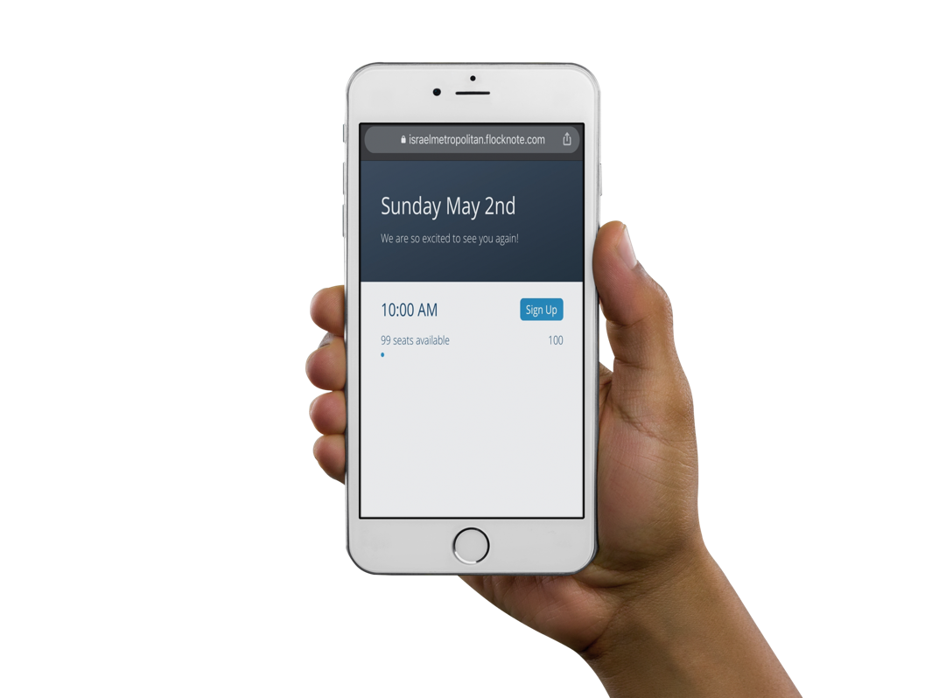
Worship and Church School Options
- We will continue to offer online worship as in-person phases begin. We will be intentional about effectively engaging our online virtual worshippers/members including discipleship opportunities for online members.
- Registration for weekly services will be mandatory in Phase one & Phase two! Members will receive a sign-up link via text and email. Seating will be limited.
- Church School Classes will continue to meet online or via conference call during phase one.

IMC Four Phase Plan

Social Distancing | PHASE ZERO  (Current) | PHASE ONE  (Limited) 5/9/21 | PHASE TWO  (Moderated) TBD | PHASE THREE  (Normal) TBD
Vulnerable Populations* | Stay Home | Encouraged to Stay Home | Individual Discretion | Normal
Those w/Symptoms of COVID-19 | Stay Home | Stay Home | Stay Home | Stay Home
Max  Groups/Crowds | 10 or less | 100 Persons  Reduced Seating/Social Distancing | 150 Persons  Reduced Seating/ Social Distancing | No Size Limit
Worship Services | Virtual Only | Virtual and In-Person  Reduced Seating | Virtual and In-Person  Reduced Seating | Virtual and In-Person  No Size Limit
Bible Study | Zoom | Zoom | In-Person & Zoom | Normal
Sunday School | Online/Conference Call | Online/Conference Call | Online/On-Site with proper social distancing | Normal
Children’s Church | Closed | Closed | Limited | Normal
Youth Ministry | Online Only | Online meetings/ outdoor events limited | Normal Activity | Normal Activity
Office Staff | Limited Operation | Limited Operation | Normal Operation | Normal Operation
Worship Team | 2-3 max | 3-6 max | Normal Activity | Normal Activity
Choir | Closed | Closed | Reduced size based on social distancing | Normal
Ministry Events | Cancelled | Cancelled | Some activities may be modified | As Scheduled
Restrooms | Closed | Limited Access | Limited Access | Normal
*Vulnerable Populations as Defined by the CDC: (https://www.cdc.gov/coronavirus/2019-ncov/needextra-precautions/people-at-higher-risk.html).

Vulnerable populations include, but is not limited to: • Individuals 65 years old and older • Individuals with serious underlying health conditions, including high blood pressure, chronic lung disease, diabetes, obesity, asthma, and those whose immune systems are compromised (such as by chemotherapy or cancer and other conditions requiring such therapy)

What Else to Expect in Phase One??
- All attendees ages 3 and older are required to wear a mask or face covering for in-person services.
- COVID-19 screenings/Temperatures check and sanitizing of hands will be mandatory prior to entry into the sanctuary.
- Worship services will last approximately 60 min.
- For a one-way flow of traffic, attendees will enter from the from the front of the church and will exit utilizing the exit doors closest to the pulpit. Seniors who are unable to utilize stairs will be permitted to leave out first utilizing the front entrance while other congregants remain seated.
- The Praise team will render all music utilizing assigned microphones.
- Two ministers will be assigned each week to assist the pastor.
- Offerings will be received upon entry and exit by placing in designated boxes. Electronic giving is highly encouraged! (Givelify, Online, and Cash App $IMCGive)

FAQ

How will we make sure people are not sitting too close to one another?
We will utilize the CDC recommendation of 6’ per person separation guideline both side-to-side as well as front to back. Pews will be clearly marked indicating where people can sit and the space that is “unavailable,” just as stores are trying to do with placards / stickers indicating where to stand. Family units can sit together, provided they are residing in the same home.
What if more people show up than the required limitation?
Persons would be provided a “Connect Card” and asked to join our online service due to gathering limitations. The “Connect Card” would have details on how to access the online services as well as how they might register to attend our services the following week.
Will there be any screening before attendees are able to enter?
Yes, all persons entering the sanctuary will be screened with several COVID-19 questions, as well as have their temperature checked prior to entry.
Where do I enter?
We will also limit access into and out of the building to the front wood doors for the sanctuary and the door adjacent to the pulpit for exiting. Doors will be clearly marked. In addition, all external and internal doors will be propped open or held open by a Greeter / Usher, to ensure a “touchless” entry and exit.

Should I wear a mask?
Information from CDC on cloth face coverings indicates wearing a mask reduces the potential for transmission of the COVID-19 virus. Mask and or a face covering will be required for in-persons worship until further notice. You are also welcome to wear gloves and any other personal protective equipment that you wish. We will have masks available for those who do not have one with them.
Will the bathrooms be open?
Yes, but their access will be limited, particularly in Phase One. Also, there will be attendants to ensure that all handles and surfaces are disinfected between uses. And, of course, signage reminding folks to wash their hands. All children must be accompanied to the restroom with an adult.
How will the offering be received?
Offering plates will not be passed between congregants. Offering baskets will be placed at the exit doors at the end of the service to receive the offering.
What about Communion?
Communion trays will not be passed between congregants. In the first phase of in-person worship, persons will be provided their communion elements as they enter the sanctuary. Elements will be collected in a designated container as attendees depart.
Persons worshiping primary online, may pick up their Communion elements the Thursday prior to Communion Sunday.

